City University of Hong Kong

School of Continuing and Professional Education

PROGRAMME - {173-19431}

BSc (Hons) Information Technology for Business (3-yr Full Degree)

Coventry University

206CDE Coursework

Group 3

Lam Yat Fung 55202135

Li Yat Long 55201950

Ma Kwan Yat 55201114

Poon Tat Man 55201716

Wong Tsun Wing 55208662

Table of Contents

Background 3

Objectives and deliverables 3

Professional Aspects and Ethical Issues 4

Work Breakdown Structure (WBS) 5

Team member and responsiveness 5

Project Schedule 7

Project log 9

E-R Diagram 11

Data dictionary 12

Use case diagram 14

Activity diagram 17

System platform 26

User operation guide 27

User Manual 28

Program code 37

Testing 37

Video Presentation 50

Personal and peer evaluation (Lam Yat Fung) 51

Personal and peer evaluation (Li Yat Long) 52

Personal and peer evaluation (Ma Kwan Yat) 55

Personal and peer evaluation (Poon Tat Man) 56

Personal and peer evaluation (Wong Tsun Wing) 57

# Background

Pizza Hut owned by Yum Brands (YUM) formed in 1958. This company is one of the largest pizza company in the world and having more than 18,000 restaurants in over 100 countries. They claim they provide their meal with delicious, bold, and one-of-a-kind to their customers.

Pizza Hut provides Italian-American cuisines especially their iconic product, pizza, for their customers. There are different types of meal in their menu including soup, salad, appetizer, pasta, rice, pizza, dessert etc. They also provide points which can exchange products or discounts for their members. Customers can eat their product by order in their restaurants, take away from their restaurants, order by phone call or their online ordering system and wait for deliveries.

This project aims to design and create a menu order system for Pizza Hut. This system needs to satisfy their users requirements.

# Objectives and deliverables

In this project, our team is going to create an in-house menu ordering system for the restaurants of Pizza Hut. The objectives of our team:

1. Functions of the system are achieved for operate the restaurants;
2. The data in this system will be downloaded, changed and uploaded to the online database automatically at the start and the end of each action;
3. The user interface will be cooperated as the interface of tablet which should be more convenience for the staff to use tablet to record the order from customers;
4. Staffs can also use this system for taking phone call orders and orders of take away;
5. This system can be share used in different restaurants of Pizza Hut

As an in-house menu ordering system, this system only allows the staffs of the restaurants to control.

Our team targeted to provide the functions below:

1. User interface for tablet
2. Login/logout
3. Product (individual/set) order, modify, delete
4. Generate order list
5. Set up, clear, change table with its order list
6. Takeaway or delivery order
7. Membership
8. Generate shop total income

# Professional Aspects and Ethical Issues

1. Privacy
   1. Membership registration

As the registration of the membership involved collection of personal information due to the customers are required to fill in their name, phone number and address. Therefore, a declaration form will be given to the customers, which we promise that their personal information will not sell to third party for commercial use. We will keep it for internal use, and it is confidential.

* 1. Credit card payment

As using the credit card for payment can expose the personal information easily, we are using the latest model of magnetic chip card reader which the position of the number on the keyboard will change randomly in order to avoid personal leakage from the cctv.

1. Fair information practices
   1. Set of principles

We will set principles for governing the collection and use of information, which we will set up rules to regulate the information handling. Thus, the staff will have clearly directions.

2.2 Privacy laws

We will work under privacy laws strictly.

1. Property rights
   1. Intellectual property

We keep the property right of the system.

# Work Breakdown Structure (WBS)

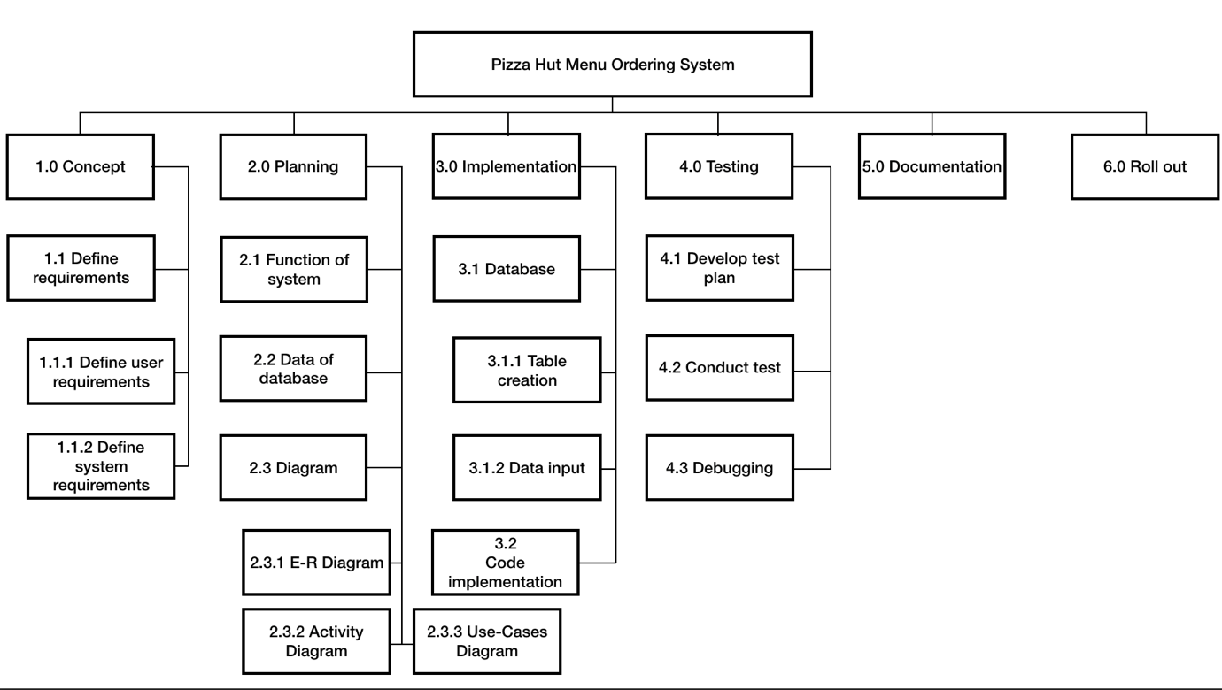

# Team member and responsiveness

R = responsibility

|  |  |  |  |  |  |  |  |  |  |
| --- | --- | --- | --- | --- | --- | --- | --- | --- | --- |
|  | WBS Activities | | | | | | | | |
|  | 1.0 | 1.1 | 1.1.1 | 1.1.2 | 2.0 | 2.1 | 2.2 | 2.3 | 2.3.1 |
| Lam Yat Fung |  |  |  |  |  |  |  |  |  |
| Li Yat Long | R | R | R | R | R | R | R |  |  |
| Ma Kwan Yat |  |  |  |  |  |  |  |  |  |
| Poon Tat Man | R | R | R | R | R | R | R | R | R |
| Wong Tsun Wing | R | R | R | R | R | R | R |  |  |

|  |  |  |  |  |  |  |  |  |
| --- | --- | --- | --- | --- | --- | --- | --- | --- |
|  | 2.3.2 | 2.3.3 | 3.0 | 3.1 | 3.1.1 | 3.1.2 | 3.2 | 4.0 |
| Lam Yat Fung |  |  | R |  |  |  | R | R |
| Li Yat Long |  |  | R |  |  |  | R | R |
| Ma Kwan Yat |  |  |  |  |  |  |  | R |
| Poon Tat Man | R | R | R | R | R |  |  | R |
| Wong Tsun Wing |  |  | R | R |  | R |  | R |

|  |  |  |  |  |  |
| --- | --- | --- | --- | --- | --- |
|  | 4.1 | 4.2 | 4.3 | 5.0 | 6.0 |
| Lam Yat Fung |  | R | R | R | R |
| Li Yat Long | R | R | R | R | R |
| Ma Kwan Yat |  | R |  | R | R |
| Poon Tat Man |  | R |  | R | R |
| Wong Tsun Wing | R | R |  | R | R |

# Project Schedule

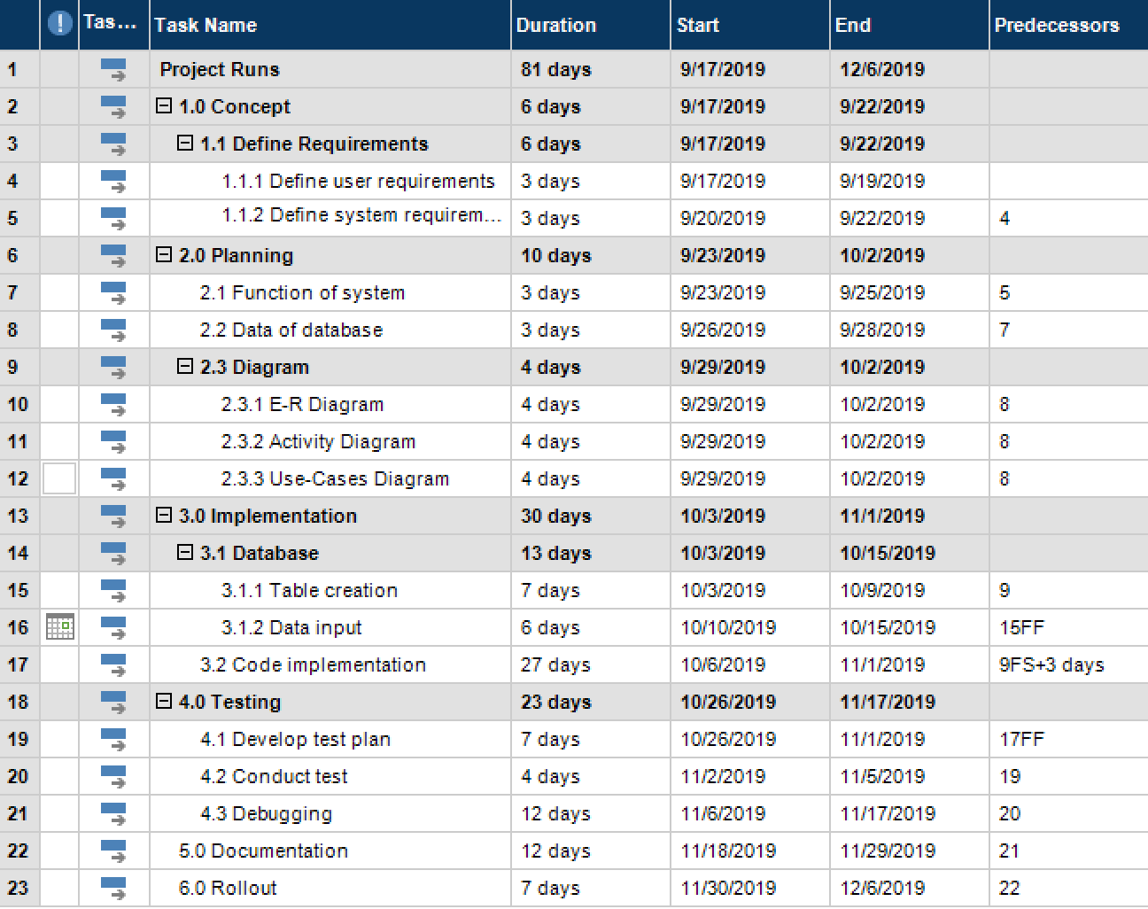

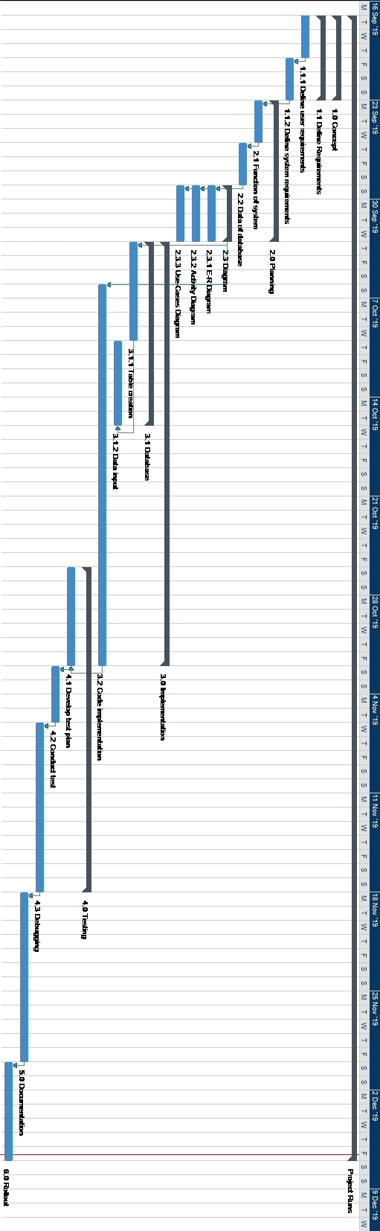

# Project log

Project: Pizza Hut Menu Ordering System

Begin: 12/9/2019

|  |  |  |  |  |
| --- | --- | --- | --- | --- |
| Date | Begin | End | Description | Patricpants |
| 17/9/2019 | 11:00 | 12:00 | Kick-off meeting | Whole group |
| * Decide User requirements * Finish discuss project plan * Prepare whatsapp group | | | | |
| 24/9/2019 | 17:00 | 18:00 | Group meeting | Whole group (except Lam Yat Fung, Ma Kwan Yat) |
| * Decide Function of the system * Decide what data is needed for the database * Consult tutor for opinion | | | | |
| 30/9/2019 | 16:00 | 18:00 | Group meeting | Whole group |
| * Discuss the progress * Consult tutor for opinion | | | | |
| 30/9/2019 | 23:00 | 1:00 | Video conferencing | Whole group (except Lam Yat Fung, Ma Kwan Yat) |
| * Discuss the design of diagrams (E-R, Activity, Use-cases) * Planning for table creation and data input | | | | |
| 4/10/2019 | 16:00 | 18:00 | Group meeting | Whole group (except Lam Yat Fung, Ma Kwan Yat) |
| * Discuss the database construction * Discuss data input progress * Discuss program construction * Assign work | | | | |
| 8/10/2019 | 16:00 | 18:00 | Group meeting | Whole group |
| * Discuss program construction progress * Consult tutor for opinion | | | | |
| 15/10/2019 | 14:00 | 16:00 | Group meeting | Whole group |
| * Discuss program construction progress * Consult tutor for opinion | | | | |
| 22/10/2019 | 14:00 | 16:00 | Group meeting | Whole group |
| * Discuss program construction progress * Discuss test plan * Consult tutor for opinion | | | | |
| 27/10/2019 | 00:00 | 01:30 | Video conferencing | Whole group |
| * Discuss progress of test plan | | | | |
| 29/10/2019 | 14:00 | 16:00 | Group meeting | Whole group |
| * Discuss program construction progress * Discuss test plan * Consult tutor for opinion | | | | |
| 5/11/2019 | 14:00 | 16:00 | Group meeting | Whole group |
| * Discuss bug/ problem of program * Consult tutor for opinion | | | | |
| 17/11/2019 | 23:00 | 01:00 | Video conferencing | Whole group |
| * Discuss the criteria of documentation * Assign work * Final check the program | | | | |

# E-R Diagram

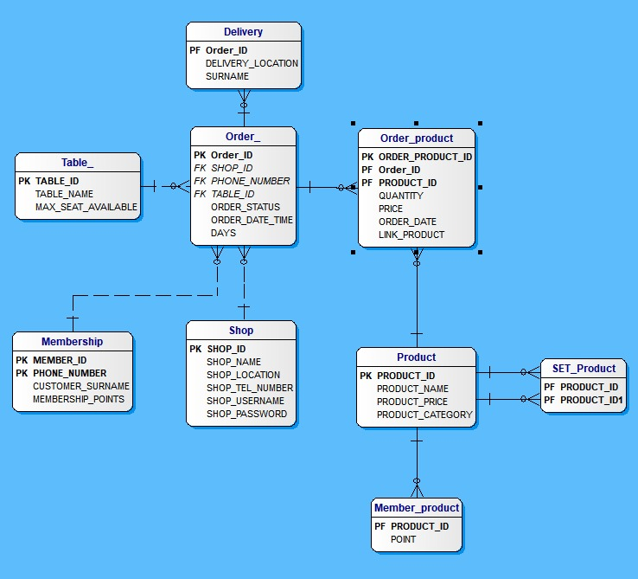

There are 9 tables in the database

Table_

* It stores all table details including the name and seats available for all pizza hut restaurants

Membership

* It stores all members information including surname and phone number
* Design for exchange the membership points for food

Delivery

* It stores all information needed for delivery including the delivery location

Order_

* It stores all information needed for each order including order id, table id and phone number
* This allows trace back the basic details of the whole order

Shop

* It stores the basic information of store including its location

Order_product

* It connects to order_ through order id, allow staff to place and check order
* It also connect to product table by product id, allow displaying of order product name
* It also stores the information of each product ordered, including its quantity and price when ordered which is necessary to prevent the price suddenly changed in product table affecting the price in order

Product

* It stores all basic details of each product including its name and price

Member_product

* It stores the points need to exchange the product

Product_product

* This identifies all sets and pizza creator choices though inserts all possible choices by product id

# Data dictionary

Delivery

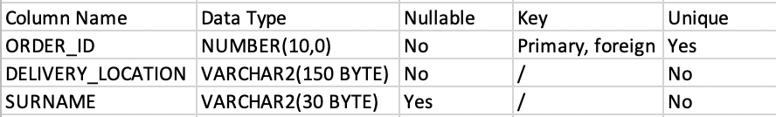

Surname stores customer’s surname

Membership_product

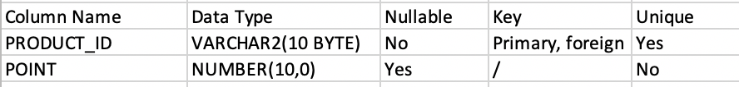

Point stores the value of points needed for membership to exchange

Membership

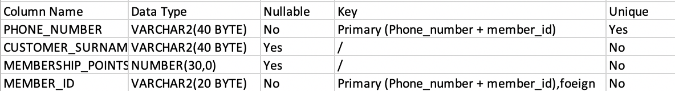

Order_

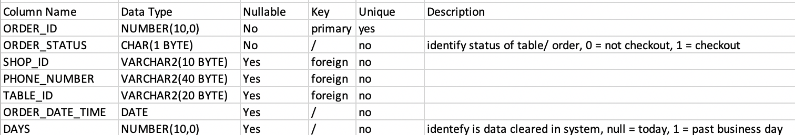

Order_product

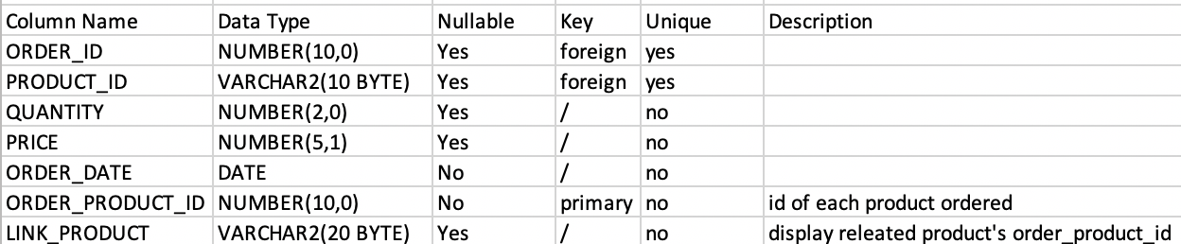

Product

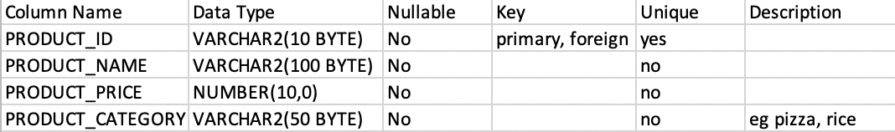

Set_product



Shop

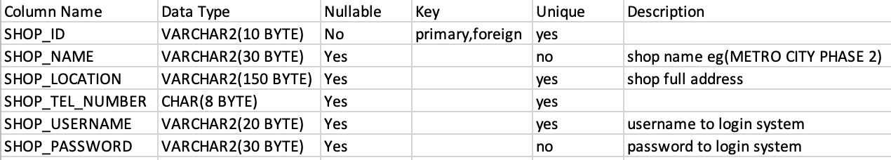

Table_

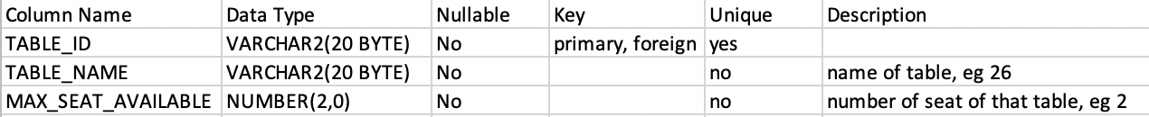

# Use case diagram

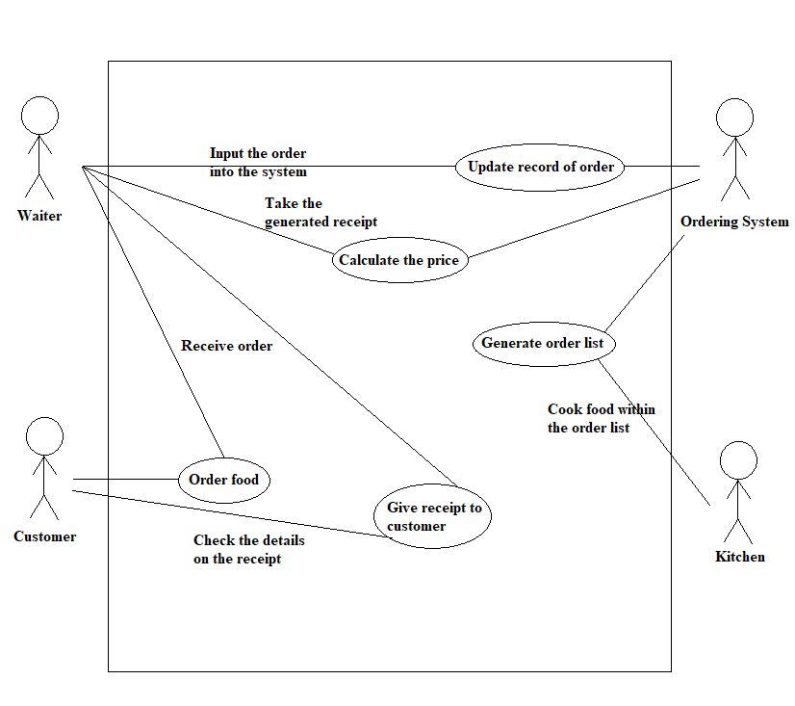

Use Case Description

|  |  |
| --- | --- |
| Use Case Name | Order food |
| Actor(s) | Customer and Waiter |
| Brief description | Customer will pass information of ordering to waiter and waiter will write it down |
| Preconditions | The customer wants to order food |
| Post-conditions | The waiter had written down the order |
| Flow of events | 1.Customer call waiter  2.Customers decide what food to order  3.The waiter records the order |
| Alternative flows and exception | Error messages from waiter |

|  |  |
| --- | --- |
| Use Case Name | Update record of order |
| Actor(s) | Waiter and Ordering System |
| Brief description | Waiter will input the order from customer into the ordering system |
| Preconditions | The waiter already get order from customer |
| Post-conditions | The ordering system receive the order |
| Flow of events | 1.Waiter input order due to the record  2.Ordering system receive the order and update the data |
| Alternative flows and exception | Error messages from ordering system |

|  |  |
| --- | --- |
| Use Case Name | Generate order list |
| Actor(s) | Ordering System and Kitchen |
| Brief description | The ordering system will generate order list to kitchen to let them know what food they should cook |
| Preconditions | The ordering system get data update from waiter |
| Post-conditions | The Kitchen receive the order list |
| Flow of events | 1.The ordering system get update of order  2.Ordering system generate a order list to Kitchen  3.Kitchen cook food due to the order list |
| Alternative flows and exception | Error messages from ordering system |

|  |  |
| --- | --- |
| Use Case Name | Calculate the price |
| Actor(s) | Ordering System and Waiter |
| Brief description | The ordering system will generate a receipt with order information that waiter input including the price to the waiter |
| Preconditions | The ordering system get data update from waiter |
| Post-conditions | The waiter receive a receipt |
| Flow of events | 1.The ordering system get update of order  2.Ordering system generate a receipt  3.The waiter receive a receipt due to the input order |
| Alternative flows and exception | Error messages from ordering system |

|  |  |
| --- | --- |
| Use Case Name | Give receipt to customer |
| Actor(s) | Waiter and Customer |
| Brief description | The waiter will give the customer a receipt generate from order of customer to let the customer check for any error |
| Preconditions | The waiter already get receipt from ordering system |
| Post-conditions | The customer can able the check the record on receipt |
| Flow of events | 1.The waiter give the receipt to customer  2.The customer check the details on the receipt |
| Alternative flows and exception | Repeat the order process to do any adjustment |

# Activity diagram

Each horizontal ellipse implies a role for the actor. This enables the easy presentation of multiple conditions and options within a process, depending on the use of case diagram.

Log in function

The figure below shows the detailed process of login. The software checks if it is correct after each user name and password is entered. If not, the system will not be successfully logged in

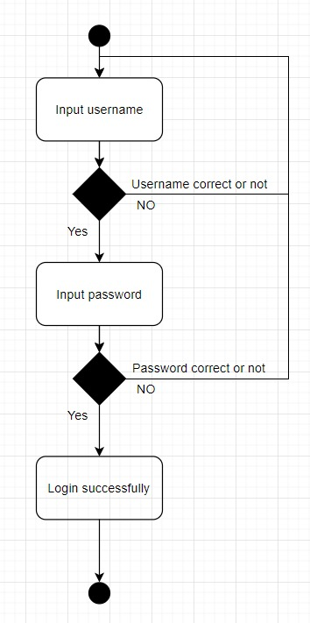

Log out function

Whenever the store is closed at the end of business hours, the store staff must sign out of the entire system in order to preserve system security and data integrity. This figure shows that the process of logout.

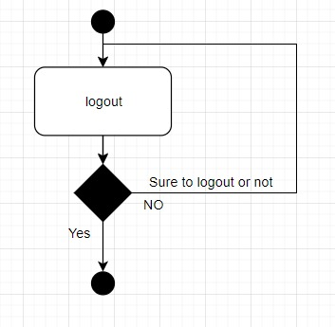

Table Select

A seat will be selected when a customer visits the store. The following figure shows how the program helps pick the seat when a client needs to sit in

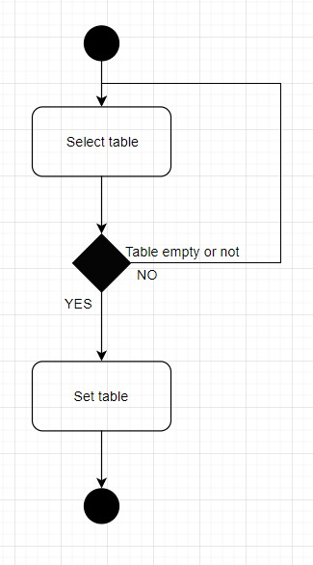

Input Order

The following figure illustrates the customer's ordering process and the functions of the ordering system when ordering.

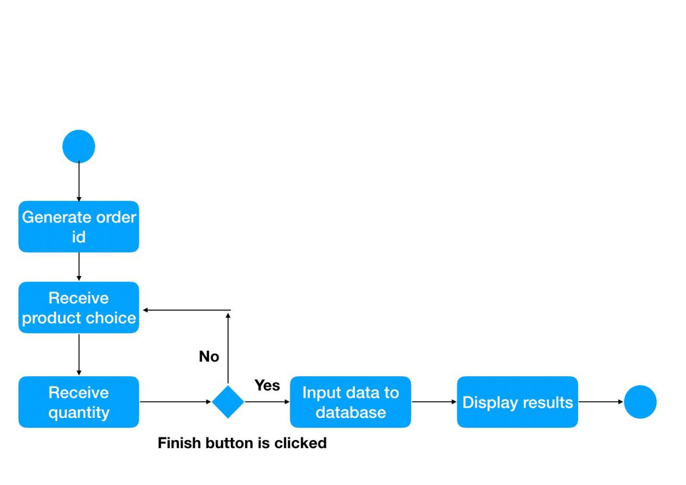

Modify Order

The following figure shows the operating mode and operating phase of the machine whenever the guest tries to change the order order.

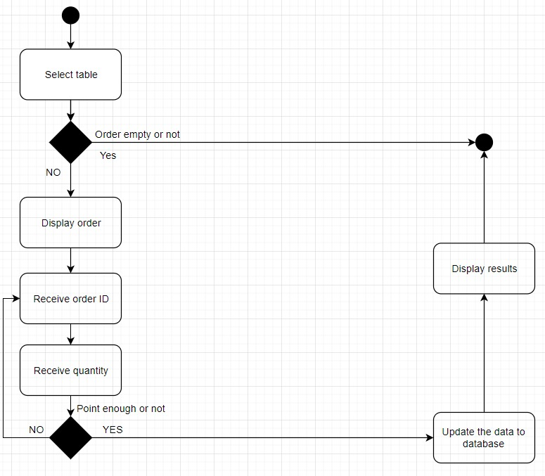

Delete Order

The following figure shows the operation and operation of the process whenever the guest requests to delete the order that was requested

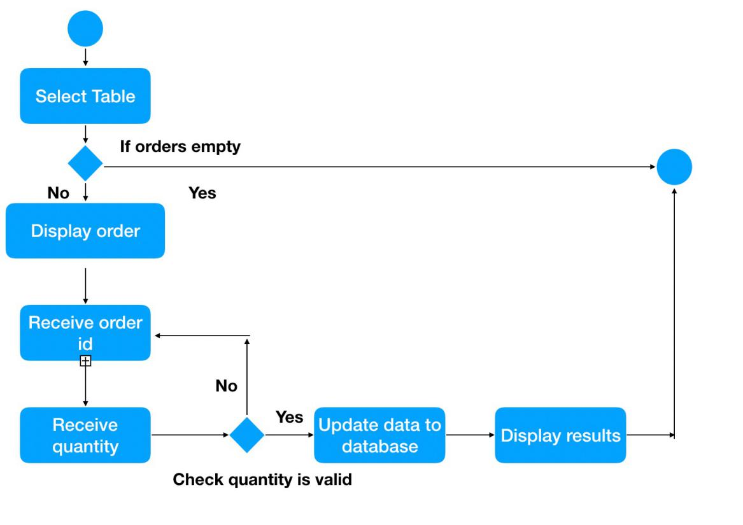

Membership

The following figure shows the structure of the program and the operations needed if the guest wishes to use the member's services as a member, including participant points and the food chosen for redemption.

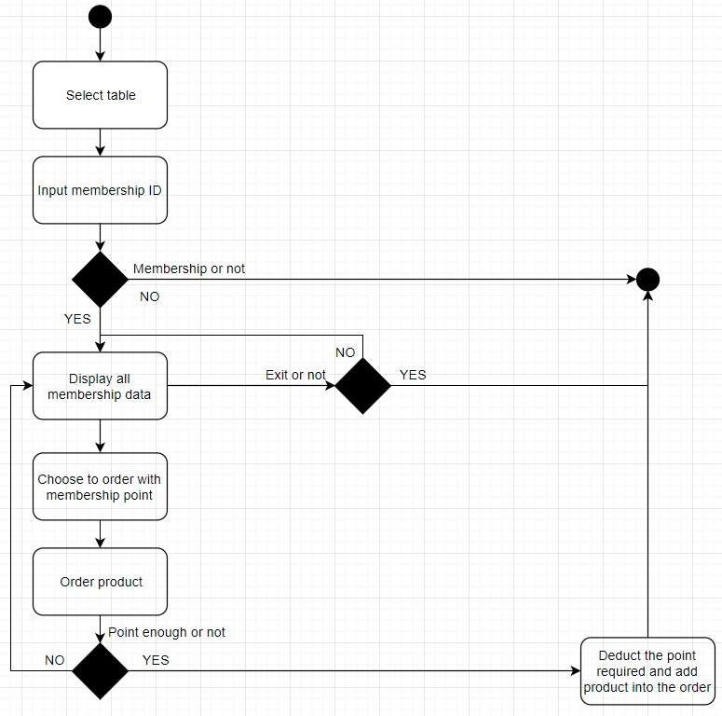

Delivery and Take Away

The following figure shows how the system works if visitors need to be transported or taken in person

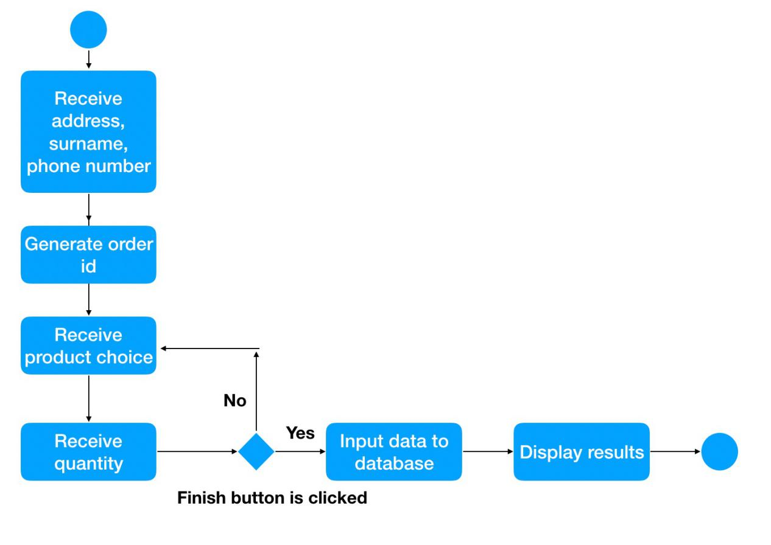

Generate order list

The figure below shows the process activity to produce a receipt any time a guest changes or updates their order.

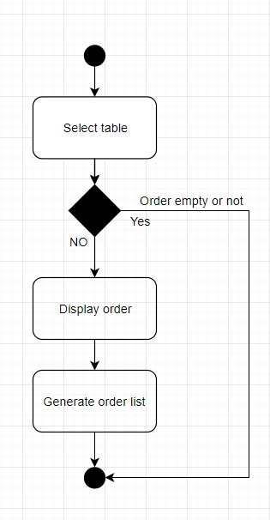

Generate shop total income

Because all the data will be stored in the database any time a customer orders, so you can use this to measure the store's earned income. The example below shows a store's internal operations when measuring a store's estimated total revenue.

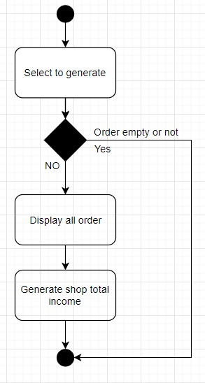

# System platform

Software:

Python

Python is chosen due to its easy to use coding and the short duration of the project. Our team are experienced in python for three years which allows us to produce great quality of work in a short period of time.

Pycharm

Pycharm integrated development environment (IDE) is easy to use with direct integration of project interpreter with cx_Oracle, increasing the efficiency of production dramatically.

Oracle SQL Developer

This tools is necessary as our team are required to use the Oracle database, which this tool allows us to implement, modify and test the table, data and SQL statements for our menu ordering system.

Hardware:

The menu ordering system requires machine running windows 10 with a touch screen monitor. Windows 10 is choosing due to its popularity and accessibility, our client – Pizza Hut can purchase a Windows 10 machine with a variety of choices in low cost. Touch screen monitor is chosen to decrease the learning curve of our system, directly touch the button in the monitor is much easier to navigate by the elder aged staff which lacks of experience on traditional navigation method – keyboard and mouse, but have experience on smartphone.

# User operation guide

Installation guide

The user should install the following software:

* Python 3.6
* Python Oracle Client (v11g)
* Pycharm
* All Python files

Installation steps:

1. Install all three software above
2. Open Pycham config it as: File->Setting-> Project->Project interpreter -> ‘+’ -> Search(cx_Oracle) -> Install
3. Put all Python files in the same folder
4. Open the folder in Pycharm

# User Manual

Login

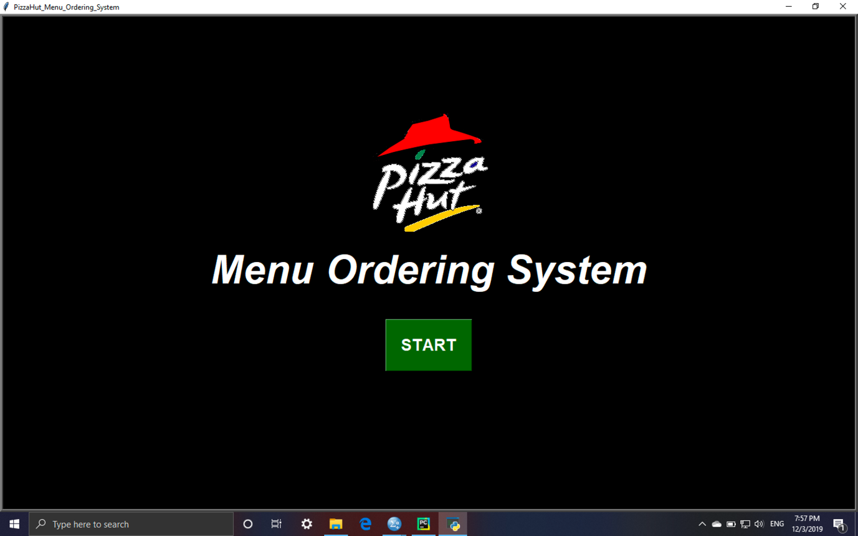

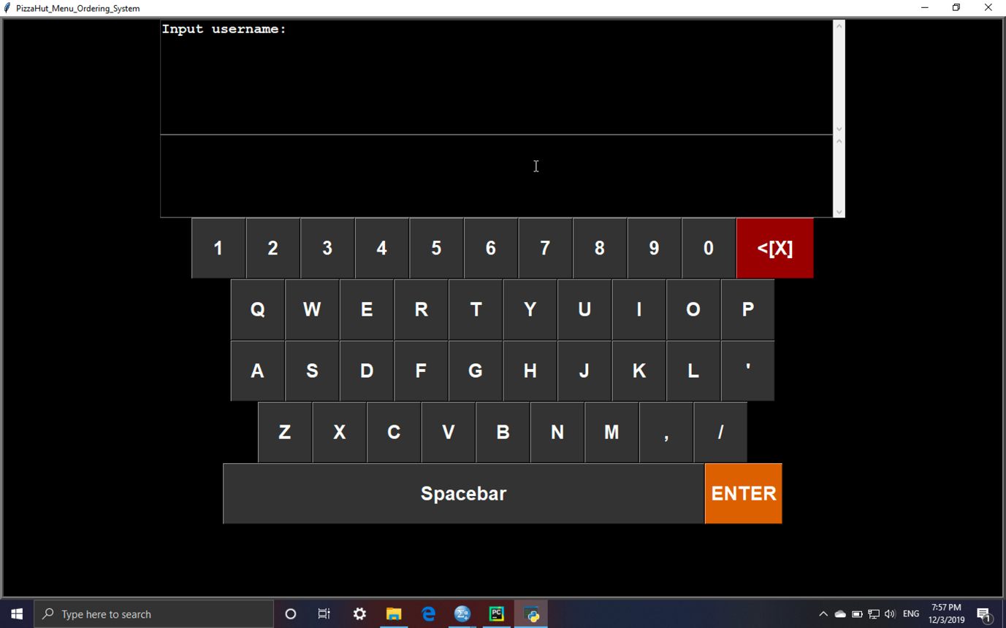

To begin using the system, user should login by the shop’s own username and password.

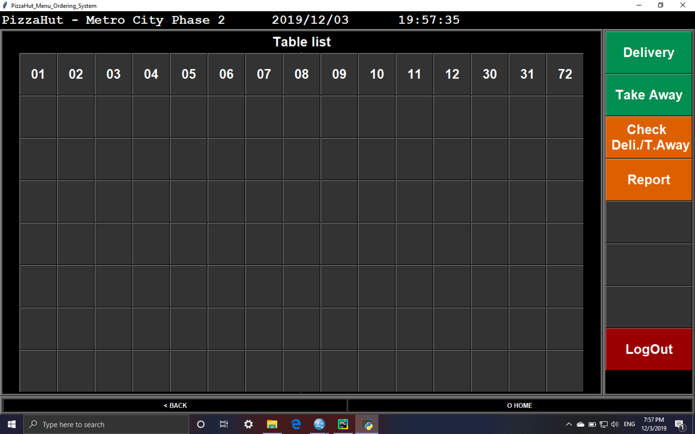

After login to the system, the main page will be shown, allowing User to check and input order.

Features of main menu:

* Status bar on top which always display the store name, date and time
* Function bar on middle right, allowing user to enter sub-page of different functions
* Table list of that shop on middle left
* Back and home navigation buttons on the bottom

Add order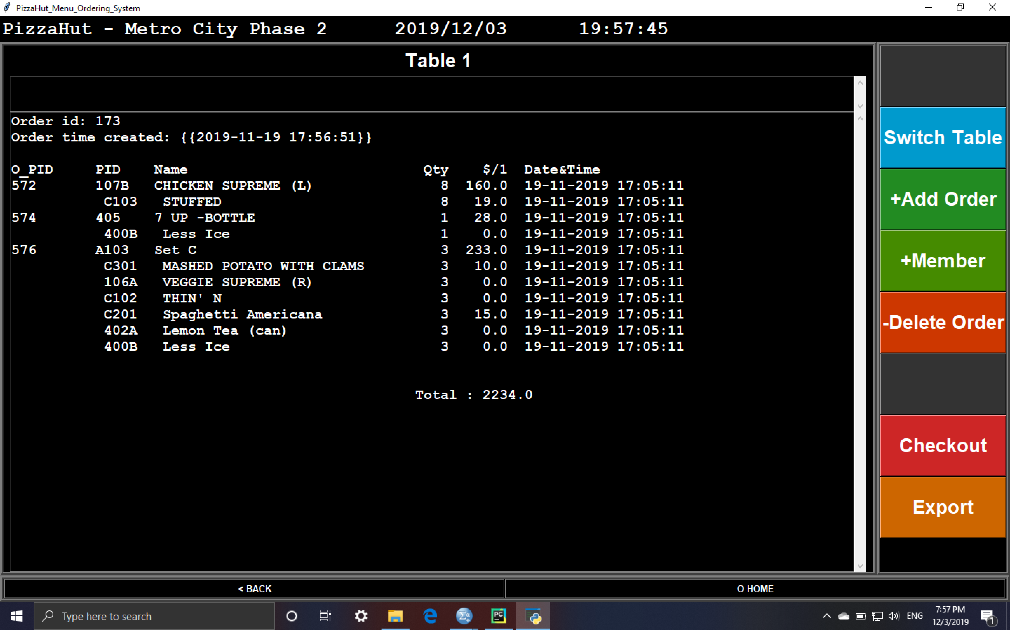

1. Select table from the table list.
2. Confirm table number under the top status bar
3. If “please set table” is displayed, press “set table” button
4. Select “+Add Order” from table page

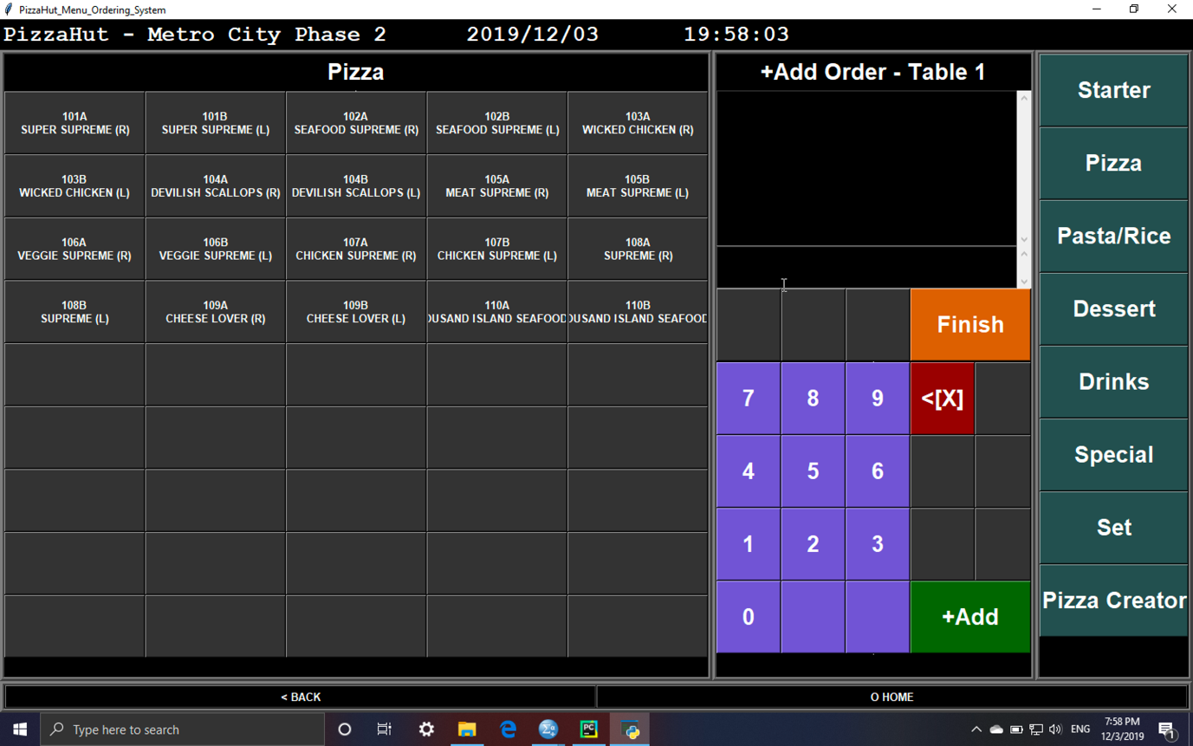

1. Select product category on the right
2. Select product from the list on the left
3. Input quantity
4. If finished, click finish button
5. The system will automatically go back to the table page which list all the order just added to the database

Exchange members point for product

1. Select “+Member” in table page

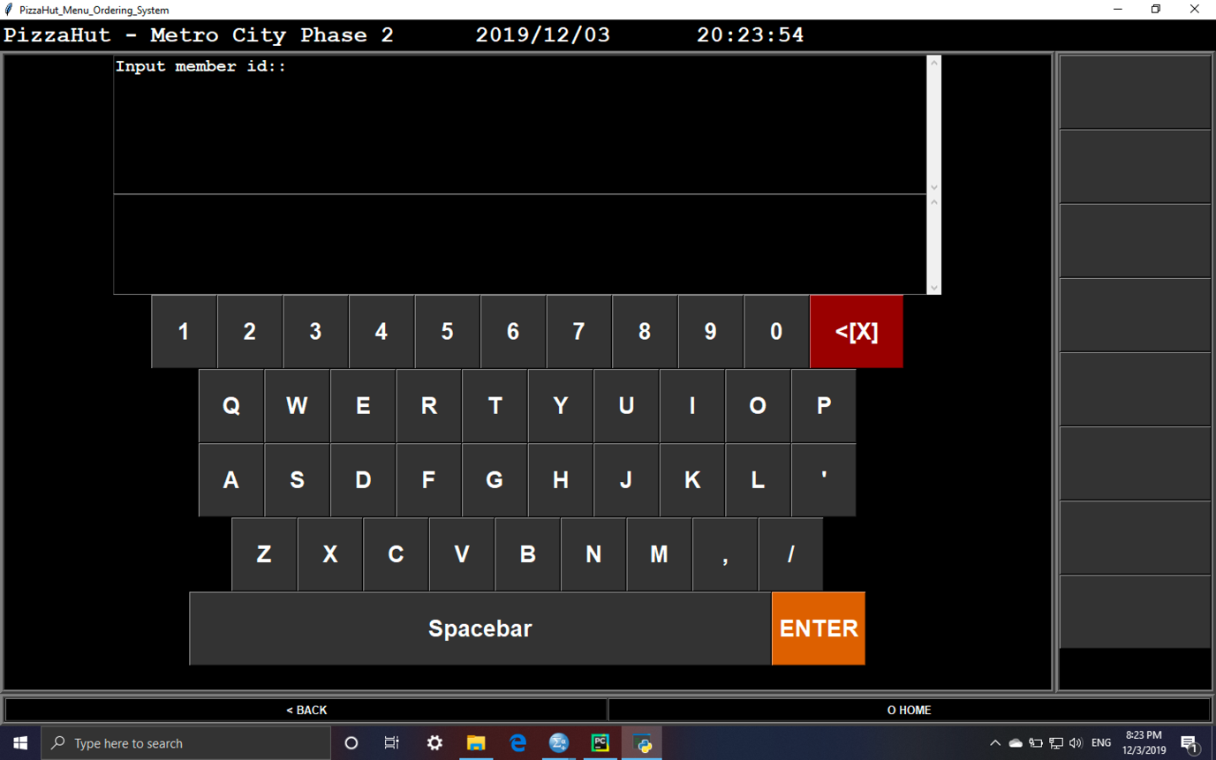

1. Input member id and phone number
2. Select product from product list

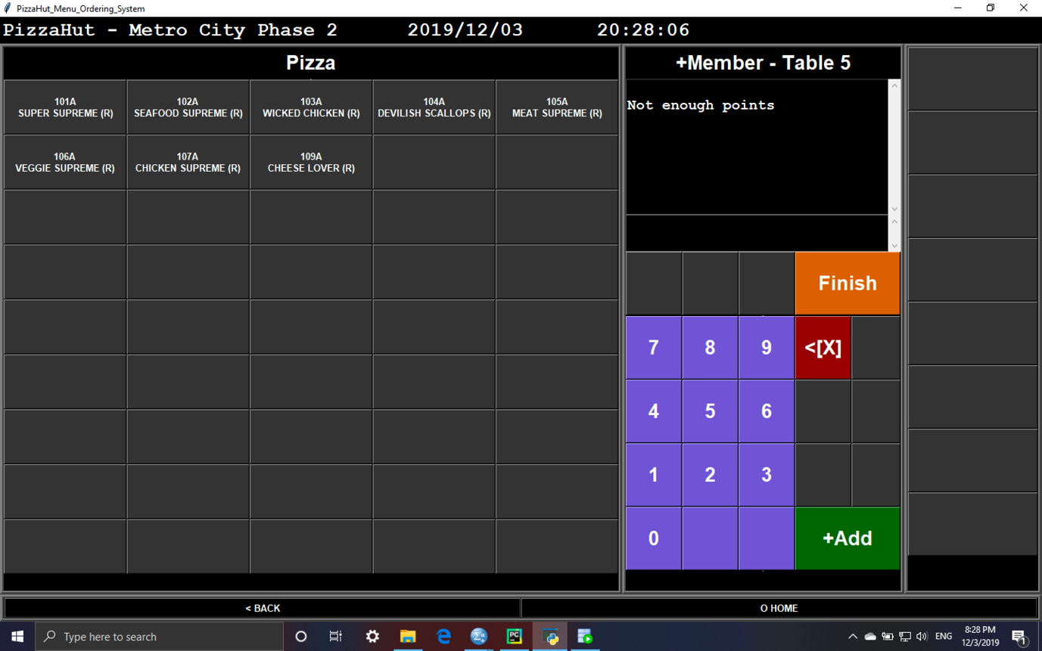

1. If the member do not have enough points to exchange for products, “Not enough points” will be displayed
2. If finished, click finish button

Delete order

1. Select “-Delete Order” from table page

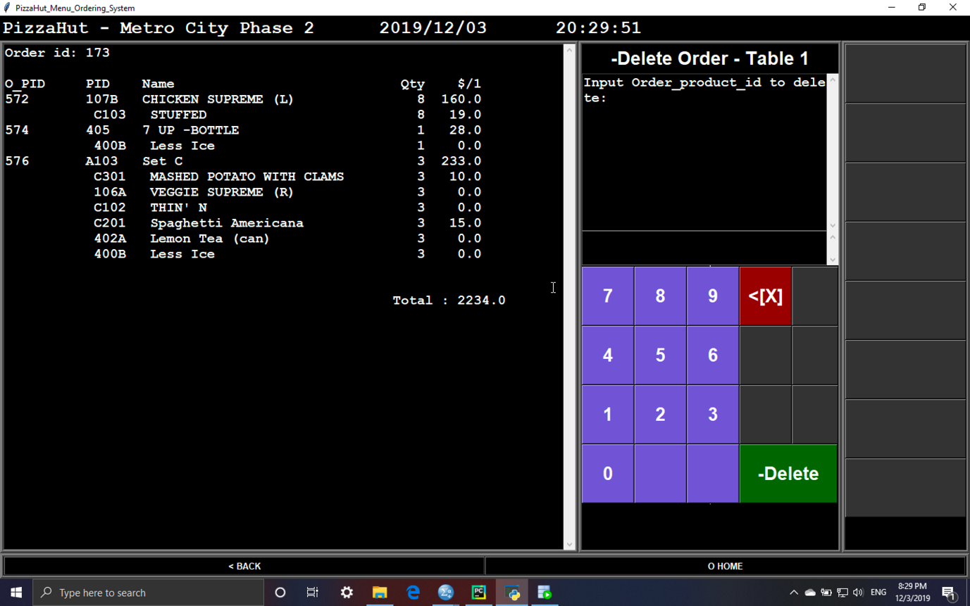

1. Input O_PID
2. Input Quantity

Switch table

1. Click “Switch Table” in table page

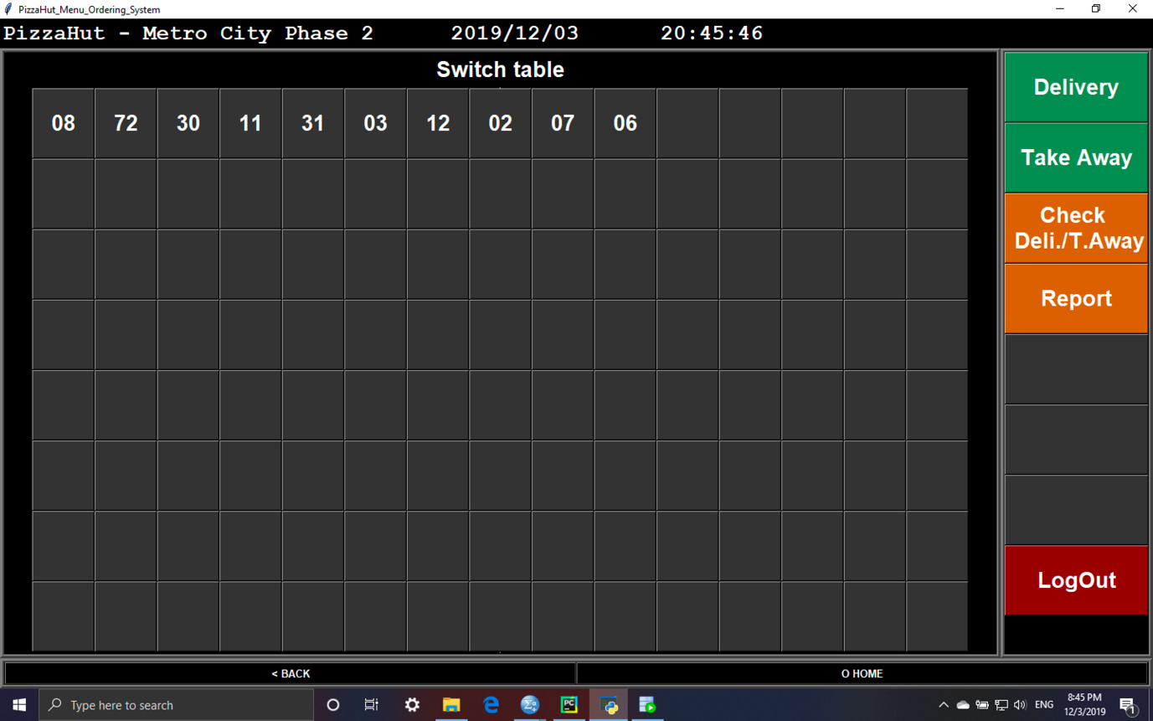

1. Select table form table list

Checkout

1. Select “Checkout” in table page

Delivery

1. Select “Delivery” in Main page

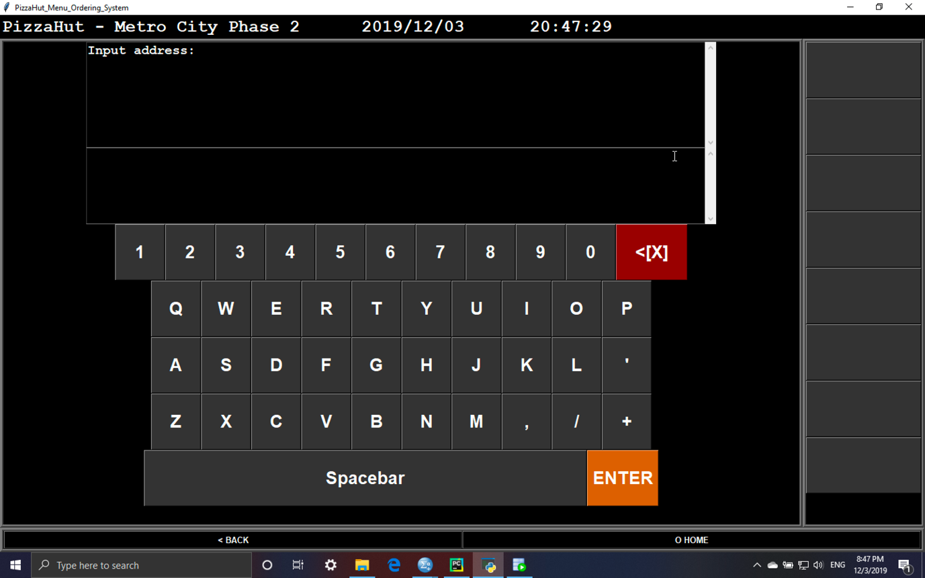

1. Input address, surname and phone number
2. Select product from product list

Export

1. Select “export” in table page

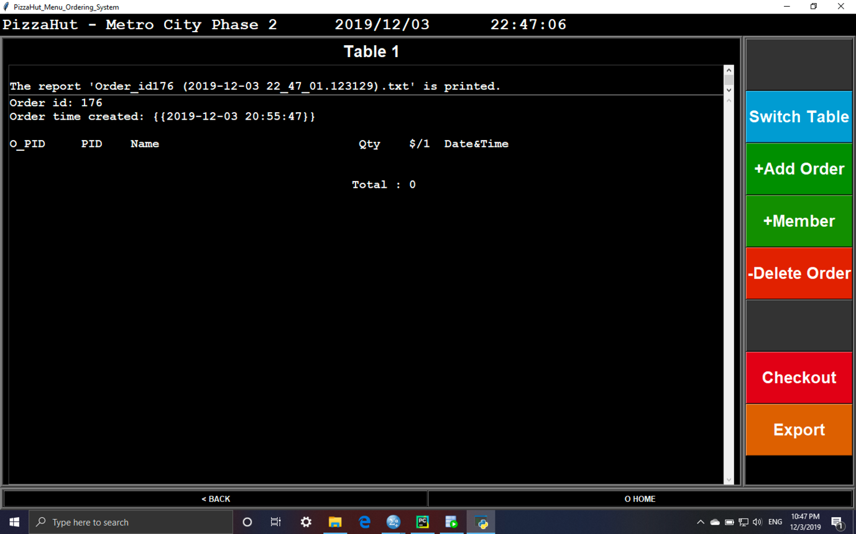

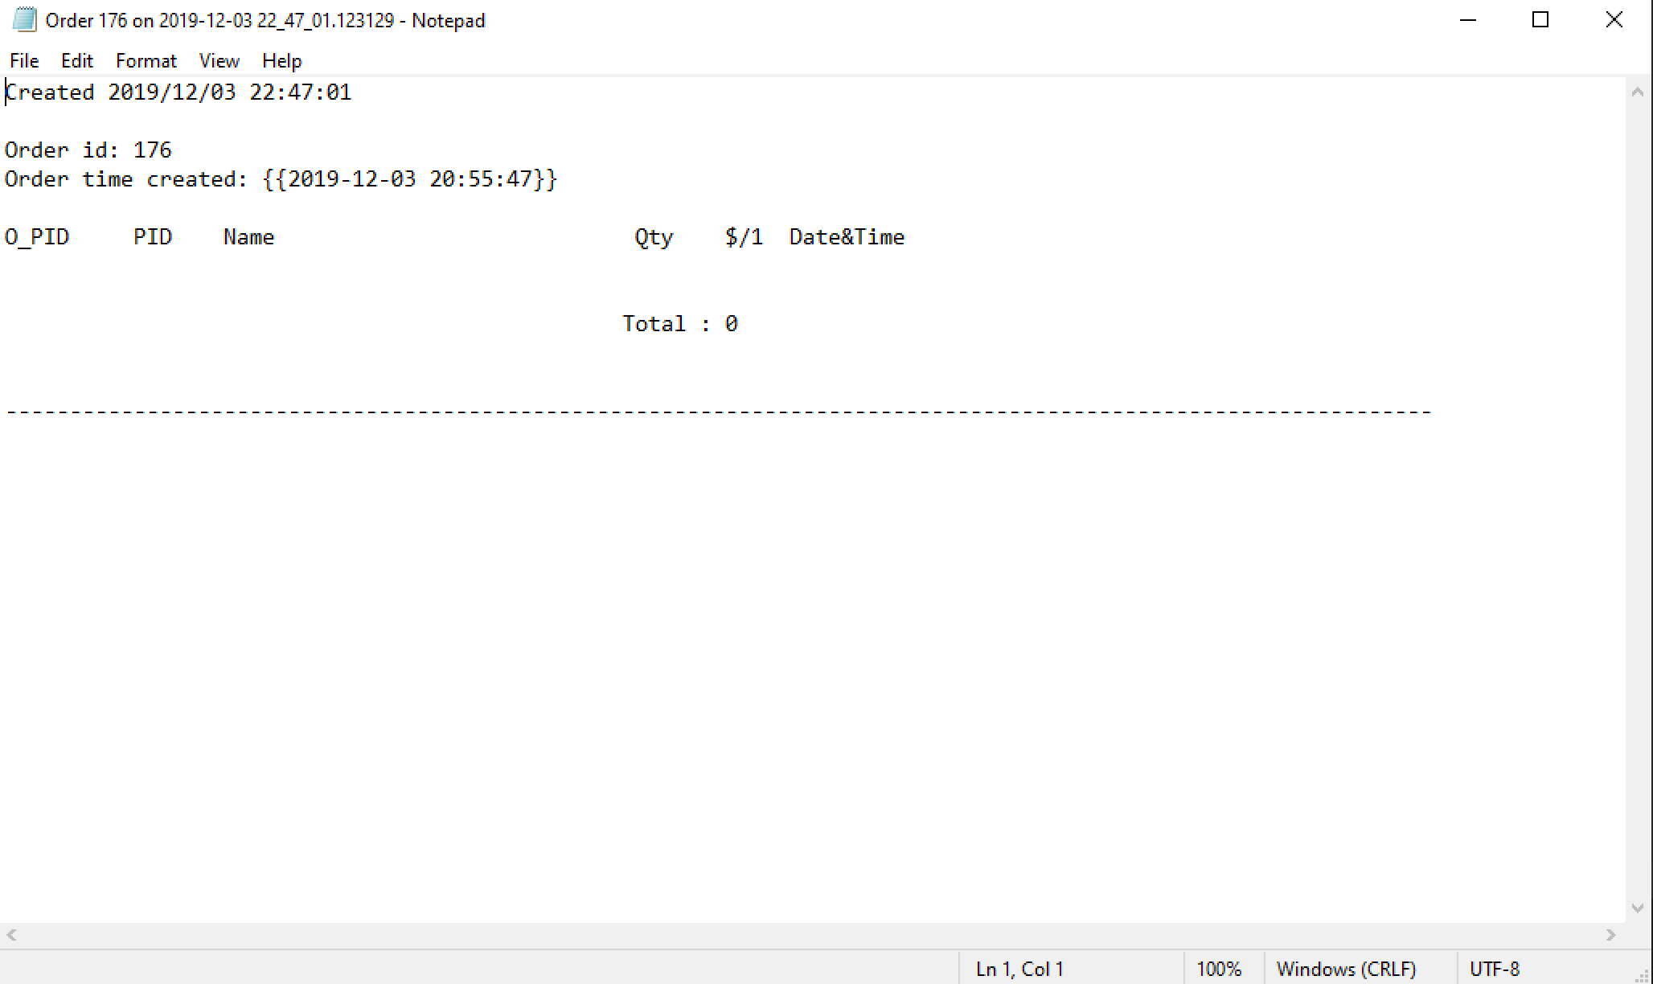

Take away

1. Select “Take away” in main page
2. Select product from product list

Check order (delivery/ take away)

1. Select “Check Deli,/T.Away” in main page

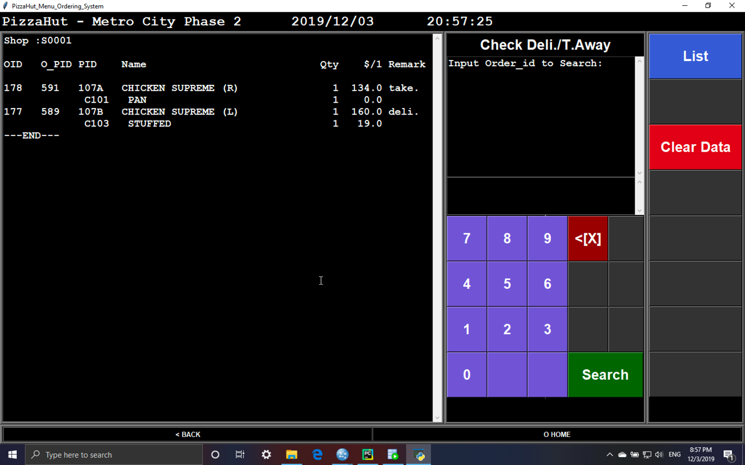

1. All delivery/ take away will be presented
2. Input order id to view specific order

Update delivery information (address/ surname/ phone number)

1. Input order id in “Check Deli,/T.Away” page

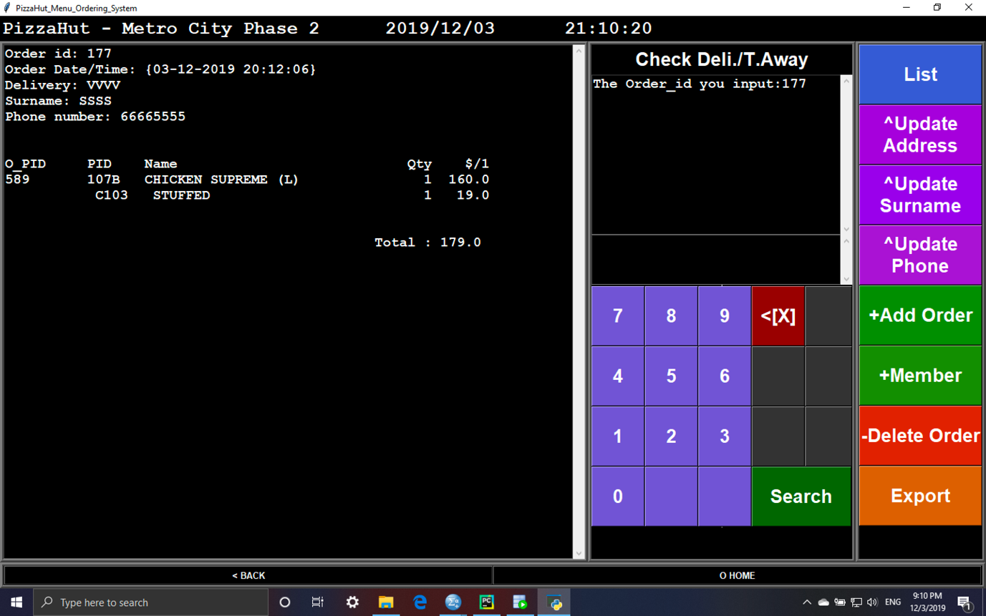

1. Select “^Update Address/ Surname/ Phone”
2. Input Address/ Surname/ Phone number

Add more order for delivery/ take away

1. Input order id in “Check Deli,/T.Away” page
2. Select “+Add Order” “Check Deli,/T.Away” page
3. Select product from product list

Exchange members point for product for delivery/ take away

1. Input order id in “Check Deli,/T.Away” page
2. Select “+Member” “Check Deli,/T.Away” page
3. Input member id/ phone number
4. Select product from product list

Delete order for delivery/ take away

1. Input order id in “Check Deli,/T.Away” page
2. Input O_PID
3. Input Quantity

Export for delivery/ take away

1. Input order id in “Check Deli,/T.Away” page
2. Select “Export”

Report

1. Select “Report” in main page

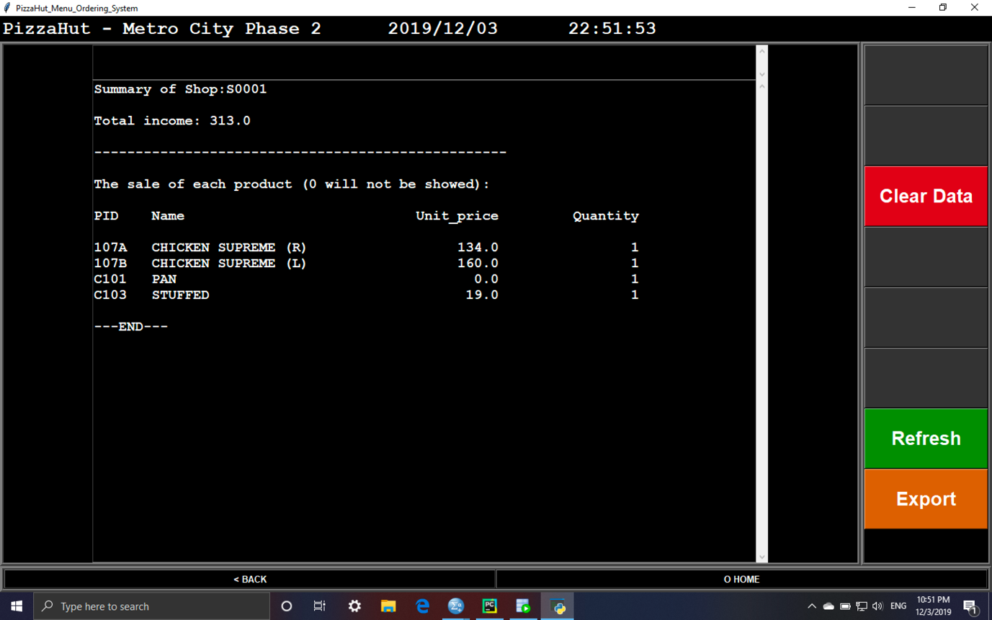

1. Select “export” if needed

Clear Data

1. Select “Clear Data” in report page

Logout

1. Select “logout” in main page
2. Input password

# Program code

https://drive.google.com/open?id=1J9TjJCuhdcqN9gyzl0SRdA1d6IXXjrRU

# Testing

Different phase of testing like including alpha test and beta test are tested accordingly before launching the system. Alpha test is a test that test input and output of the system to see whether those meet expectation. Beta test is a test to exanimate the software in real life.

The below test case including valid and invalid (if applicable) are inputted to see if the output meet expectation.

login

|  |  |  |
| --- | --- | --- |
| Input | Output | Pass |
| Valid data:  Username: QWE  Password: 123 | It appears the home page of that shop | Yes |
| Invalid data:  Username: QWER  Password:1234 | A message of invalid data input is displayed | Yes |

Log out

|  |  |  |
| --- | --- | --- |
| Input | Output | Pass |
| Valid data:  Clicking ‘LogOut’ from home page | It asks for the password | Yes |
| Valid data:  Input a correct password:123 | It go back to logo page. | Yes |
| Invalid data:  Input a wrong password:123456 | An error message is showed | Yes |

Table

|  |  |  |
| --- | --- | --- |
| Input | Output | Pass |
| Valid data:  Select a table | Showing the detail of table | Yes |
| Valid data:  Click ‘Set Table’ | Create an order and showing the detail while more function is showed | Yes |
| Valid data:  Click ‘Switch Table’ | Showing the table which can be switch to | Yes |
| Valid data:  Select a table after clicking ‘Set Table’ | The order is change to another table as the order id and table id show. | Yes |
| Valid data:  Clicking ‘Export’ | The order details are export as a text file and a message showed | Yes |
| Valid data:  Clicking ‘Check Out’ | The order is finished | Yes |

Delivery

|  |  |  |
| --- | --- | --- |
| Input | Output | Pass |
| Valid data:  Clicking ‘Delivery’ from home page | Ask for your address. | Yes |
| Valid data:  Input an address (e.g. HK) after clicking ‘Delivery’ from home page | Showing the address that you input and ask for your surname. | Yes |
| Valid data:  Input an address (e.g. TEST). | Showing the address and surname that you input and ask for your phone number. | Yes |
| Valid data:  Input phone number (e.g. 11111111). | It can order product after inputting the address, surname and phone number. | Yes |
| Valid data:  Click finish after select the product. | The order detail is showed in the ‘Check Deli./T. Away’ page | Yes |

Take Away

|  |  |  |
| --- | --- | --- |
| Input | Output | Pass |
| Valid data:  Clicking ‘Take Away’ from home page | It can order product. | Yes |
| Valid data:  Click finish after select the product. | The order detail is showed in the ‘Check Deli./T. Away’ page | Yes |

Check Deli./T. Away

|  |  |  |
| --- | --- | --- |
| Input | Output | Pass |
| Valid data:  Clicking ‘Check Deli./T. Away’ from home page | List all the detail of the order which are delivery or take away | Yes |
| Valid data:  Search for an order id showed (e.g. 183) | Showing the order details | Yes |
| Invalid data:  Search for an order id do not showed (e.g. 0) | An error message is showed | Yes |
| Valid data:  Clicking ‘List’ from ‘Check Deli./T. Away’ page | List all the detail of the order which are delivery or take away | Yes |

Order

|  |  |  |
| --- | --- | --- |
| Input | Output | Pass |
| Valid data:  Select a product after clicking ‘+Add Order’ (e.g. 101A&C101) | It can ask for quantity. | Yes |
| Valid data:  Input the quantity (e.g. 1) and click ‘+Add’ | It shows the product name and the quantity.  Also, it is allowed to select another product | Yes |
| Valid data:  Click ‘Finish’ after selecting product | It shows the detail of that order. | Yes |
| Valid data:  Clicking ‘+Member’ | It asks for member id | Yes |
| Valid data:  Input a correct id (e.g. V0005) | It asks for the phone number | Yes |
| Valid data:  Input a correct phone number (e.g. 99998888) after input a correct id | It shows the product which use member point to buy | Yes |
| Invalid data:  Input a wrong id or phone number | An error message is showed | Yes |
| Valid data:  Clicking ‘-Delete’ | It shows the product of that order and ask for the Order_product_id you want to delete | Yes |
| Valid data:  Input an Order_product_id (e.g. 599) | It asks for quantity. | Yes |
| Valid data:  Input a quantity (e.g. 3) after input an Order_product_id | The order detail will be updated. If the quantity is <=0, it will delete from the detail. | Yes |

Report

|  |  |  |
| --- | --- | --- |
| Input | Output | Pass |
| Valid data:  Clicking ‘Report’ from home page | Showing the sales of each products | Yes |
| Valid data:  Clicking ‘Export from home page | The report is export as a text file and a message showed | Yes |
| Invalid data:  Clicking ‘Refresh’ | Update this page if other computer updating the database. | Yes |
| Valid data:  Clicking ‘Clear Data’ from ‘Report’ page | It asks for password | Yes |
| Valid data:  Input a correct password (e.g. 123) after clicking ‘Clear Data’ | The data will not be show again | Yes |
| Invalid data:  Input a wrong password (e.g. 321) | An error message is showed | Yes |

# Video Presentation

<https://youtu.be/Osv9lS7xDw0>

# Personal and peer evaluation (Lam Yat Fung)

In my view, the contribution is like the table show below:

|  |  |  |  |  |  |  |
| --- | --- | --- | --- | --- | --- | --- |
| Member | System Analysis | System  Design | Program Development | Testing | Writing report | Total  (*weight) |
| Lam Yat Fung | 20% | 10% | 30% | 20% | 10% | 20% |
| Li Yat Long | 20% | 30% | 40% | 20% | 30% | 32% |
| Poon Tat Man | 20% | 25% | 15% | 20% | 15% | 19% |
| Wong Tsun Wing | 20% | 25% | 15% | 20% | 15% | 19% |
| Ma Kwan Yat | 20% | 10% | 0% | 20% | 30% | 10% |
| Total: | 100% | 100% | 100% | 100% | 100% | 100% |
| Weight | 10% | 30% | 40% | 10% | 10% | / |

To sum with, Li Yat Long play a role of team leader, leading and breaking the project into different task to distributing them to us. Poon Tat Man, Wong Tsun Wing, Ma Kwan Yat and I usually play a role of a loyalty member, finishing the task given by Li Yat Long and willing to give suggestion while there are difficulties.

In my opinion, the project’s level of success is 85% as the requirement because there are some limitation, improvement or further development:

1. As the limitation of knowledge and topic, it cannot compare to those comprehensive systems on the market, which including the functions related to point-of-sales system, voided order, supplies, inventory, or other function that are not belong to a menu order system.
2. As the limitation of time, there are some of the data do not add to the database, such as the data related to staff or the detail of memberships’ points.
3. Due to the design of the database and system, it only supports personal set product. Also, one product only can select one customization options

Apart from those concern, I learnt something from my classmate that I never think about, including the logic of the system, while developing with the system. However, there are something we may not consider on time. If I had started the project again, I would have designed the database as much better. If there is a similar project, I would recommend using ‘Dezign’ developing database as well as this project since it can export the SQL after drawing an ERD.

# Personal and peer evaluation (Li Yat Long)

Evaluation of project achievement

Our aim of the project is to develop a menu ordering system for Pizza Hut, allow staff to not only order food for dine in customers but also take away or delivery customers, reducing the time needed and accuracy of order.

I strongly believed that our system not only meet the aim above, but also achieve even more. The touch screen interface is easy to navigate, reducing the learning curve and allow all ages of staff to use it easily. The function like swap table and report allows the shop to even increase the convenience in daily business. Customer sometimes request to change table due to reasons including dripping of water, the introduce of this feature allows staff not to type the order again. Meanwhile, the report feature allows the shop to examine the sales of each business day, contribute business decision making including stock and what product can introduce.

Evaluation of self and peer’s performance and contribution

Myself

I contributed in to nearly everything of the project, even if that part is not my talent, I still ask and understand what my teammates are doing. I strongly believe that through these steps, I can control and adjust the schedule of work with quality. To achieved this, not only weekly conference is held, but also lots of whatsapp communication, exchanging opinions and ideas. Moreover, consultation with tutors happens frequently, which also ensure the step and design of database is correct and success.

The UI design is mostly design and implemented by myself, preserve consistency of the UI elements, which I believed can contributes to user friendliness. Besides, I listened to my teammates opinion and improve the design, resulting in the success of the software with balance of features and easy to navigate. My involvement in decide the features, database and programming also help achieve this.

Lam Yat Fung

His ability on coding allows development time of each function reduce drastically, allows our team to develop even more features with refinements on time.

Ma Kwan Yat

She helps a lot in documentation and video recording, increasing the efficiency of those process and quality of our work.

Poon Tat Man

His knowledge in databases, software features and programming allow our team to develop both database and software professionally with features that is highly related and useful to the client.

Wong Tsun Wing

He helps a lot in data input, documentation and testing with great quality, allow others focus on developing great quality of software and increase the efficiency of our group.

Review of Project Management / Development

In my opinion, the management of the project is decent and achieve its target which is managing and controlling the progress of the project, allowing the group to finish the project on time with all its planned feature. On the other hand, the great contribution of work which

each student could present and apply its talent on specific fields including database implementation, coding or documentation, also facilitate remarkable results.

However, due to time, question and knowledge constraints, there still lots of improvement that could apply to the existing results.

1. Although the system is able to calculate number of items sold, as there are no inventory field in the database, if cannot calculate how many left of specific product.
2. The problem stated above also result in another problem. The system cannot prevent staff order product which is out of stock.
3. The system just provides features of ordering products, which the shop requires another POS system for payment, increasing the inconvenience of staff. For example, after the staff accept the payment of a table, the status of the menu ordering system is unchanged, requiring to press the “checkout” button on it.
4. The system requires windows desktop to activate lacks of portability, each staff can carry its phone or tablets to take order is more ideal and reduce the chance of making mistake and queue for ordering.
5. To update the database of the system, staff need to use Oracle SQL Developer, which is difficult for new comers and it is easy to mistakenly delete the data. The development of data input features can solve this program.

Team contribution table

|  |  |  |  |  |  |  |  |
| --- | --- | --- | --- | --- | --- | --- | --- |
|  | Choose question | Decide requirements | Design database | Database implementation | Data input | Code implementation | Testing |
| Lam Yat Fung | 5% | 2% | 2% | 0% | 0% | 40% | 20% |
| Li Yat Long | 30% | 32% | 32% | 10% | 5% | 55% | 20% |
| Ma Kwan Yat | 5% | 0% | 0% | 0% | 0% | 0% | 20% |
| Poon Tat Man | 30% | 32% | 32% | 80% | 5% | 5% | 20% |
| Wong Tsun  Wing | 30% | 32% | 32% | 10% | 90% | 0% | 20% |

|  |  |  |  |  |
| --- | --- | --- | --- | --- |
|  | Documentation | Diagram (eg ER) | Video presentation | UI design |
| Lam Yat Fung | 5% | 0% | 0% | 0% |
| Li Yat Long | 20% | 20% | 60% | 96% |
| Ma Kwan Yat | 25% | 0% | 40% | 0% |
| Poon Tat Man | 25% | 80% | 0% | 2% |
| Wong Tsun  Wing | 25% | 0% | 0% | 2% |

# Personal and peer evaluation (Ma Kwan Yat)

|  |  |  |  |  |  |  |
| --- | --- | --- | --- | --- | --- | --- |
| Team Member | System Analysis | Database  System | Database  Development | Testing | Documentation | Video  Editing |
| Ma Kwan Yat | 20% | 0% | 0% | 20% | 25% | 40% |
| Li Yat Long | 20% | 30% | 30% | 20% | 15% | 60% |
| Poon Tat Man | 20% | 20% | 25% | 20% | 25% | 0% |
| Wong Tsun Wing | 20% | 20% | 20% | 20% | 20% | 0% |
| Lam Yat Fung | 20% | 30% | 25% | 20% | 15% | 0% |

* Ma Kwan Yat

I mainly participate in documentation and video editing which usually is my strengths. However, I am not good at programming so I am not responsible for that. I am glad to have a group of capable team mates so that we can finish the project successfully.

* Li Yat Long

He is a good leader who shown his leadership in all aspect as well as when we have different opinions, he will make a conclusion. Also, his ability of developing database coding is good which always come up with creative idea.

* Poon Tat Man

He is capable for fixing the bugs when we face difficulties. His knowledge in programming is very useful for our group and thus make the developing process smoothly.

* Wong Tsun Wing

He is a responsible person which he tried his very best to finish the tasks. And if he faces some difficulties, he will raise out the questions immediately. Thus, our development always on schedule.

* Lam Yat Fung

He is good at coding so that he always finish the tasks on time or even faster than our planned goal. Therefore, this enhance our efficiency.

Overall Reviews of the Project

I think our group did better than our expectations because creating an ordering system is not that easy since there are many functions and some of them integrate with each other. Therefore, the bugs appear easily. Fortunately, the food type of the pizza hut is only focus in western food and we can gain experience from daily life because we all have been to pizza hut for dinning. Moreover, the user interface look 90% similar to the one in reality so we are very proud of ourselves. However, I think if there is one more chance for further development, we should change some user interface as well as make it more colourful and can use graphics to represent the food instead of words. Thus, it can enhance readability.

# Personal and peer evaluation (Poon Tat Man)

|  |  |  |  |  |  |  |
| --- | --- | --- | --- | --- | --- | --- |
| Team Member | System Analysis | Database  System | Software  Development | Testing | Documentation | Video  Editing |
| Poon Tat Man | 20% | 45% | 5% | 20% | 20% | 0% |
| Li Yat Long | 20% | 10% | 60% | 20% | 20% | 60% |
| Wong Tsun Wing | 20% | 35% | 5% | 20% | 25% | 0% |
| Ma Kwan Yat | 20% | 0% | 0% | 20% | 20% | 40% |
| Lam Yat Fung | 20% | 10% | 30% | 20% | 15% | 0% |

* Li Yat Long

He is an excellent leader, and when we have different opinions, he can weigh the pros and cons and make a choice among them. He also has a strong ability to develop software programs, so he also plays a very important role in our software programming.

* Ma Kuan Yat

She is very good at organizing documents and writing in writing, particularly with regard to her professional and ethical issues.She provides advice on writing software mostly, and compared to other members, her programming skills are relatively weak. Hence, as an opinion provider and clerical assignment, her priority in this community was.

* Wong Tsun Wing

He is the person responsible for doing his best to maintain the completeness of the task. If there are any difficulties, he will ask questions immediately. He is also responsible for a large amount of data entry, so this keeps our operations in good progress.

* Lam Yat Fung

He is one of us with good programming skills, so he is responsible for a lot of software programming tasks. He mainly cooperates with Li Yat Long

to complete our programming assignments

Overall Reflections of the Project

I think our team is doing better than we expected because it is not easy to create an ordering system because it has many features, some of which are very close to the point of sale system, but not necessary for the ordering system. Therefore, due to the difficulty in identifying the necessary tasks, errors are prone to occur because the required functions may sometimes be missing. Luckily, the pizza house's variety of food is very popular, and we've gained experience from the past because we've all been to the pizza house to eat. Nonetheless, I think we should change some user interfaces to make them more user-friendly if there is a potential for further development, and we can use graphics to depict food instead of text.

Personal Reflections

I learned a few things from my teammates, like system logic, when I discussed research with my partners, but there were some aspects that we didn't fully understand. For example, we did not perform a thorough analysis of each step of the research step, so we noticed some difficulties related to previous analysis from time to time in the planning process.I'm going to design a server that satisfies the application needs more thoroughly before I start the project again. Before similar projects exist, I recommend drawing ER diagrams first and using use case diagrams so that we can describe client and device specifications more clearly.

# Personal and peer evaluation (Wong Tsun Wing)

Evaluation of project achievement

I believe that our team have most of the achieve the objectives set by us. First, this data in the system has connected to the online database which data will be updated automatically in each actions. We created an online active system which can be used as local, shared or used in different locations with same program.

Second, we have made the functions that satisfy the requirements of operating a restaurants. We developed our system in using different functions to achieve the requirements like membership, takeaway, table change functions, and I think we succeeded .

However, one thing that we didn’t finished it perfectly is that we listed the user interface of the system will be cooperated as the interface of tablet size, we create and implement our system base on Windows OS for computer version. If the business really want to use the system to take the order on their tablet, we need to develop the system to application base on Android, IOS or iPadOS version better than the waiters using the applications for remote control computer on their tablets.

Evaluation of self performanceand expertise contribution

As a responsible teammate, I joint all meetings no matter the meeting is hold on after the end of the classes or the meeting by calling on Skype. I always report the progress of my jobs to the team by using Whatsapp.

I have been assigned to input the data to the database, part of documentations, testing the program every times when it’s updated and giving out recommendations in after each jobs finished. I used Oracle SQL Developer to follow the frame and rules of our database that created, using SQL coding to input the data needed, and using Pycharm to implement our program for testing. I also give out suggestions when the functions and system are developing, including suggested that table can be exchanged to another table and membership functions. I have also provided at least 5 testing reports during the system was improving, example finding out buttons error, no responses error and write page error.

I will ask my teammates for help initiatively when I found difficulties on my jobs, and they are willing in helping me to solve or fix the problem that I faced.

Evaluation of peer’s performanceand expertise contribution

Lam Yat Fung, Timmy

He is an active teammate who always finished his work on schedule. He also take the responsible on programming and help us to test and solve the problems we found in our system.

Li Yat Long, Vincent

He is the leader of our team who divide the works and ask us to finish the tasks on schedule. He will take the initiative to call us on Skype or on the classes for meeting and discussion for solutions when he found out any questions or problems that need to solve. He is also the accountable and responsible person who take main part in programming out system.

Ma Kwan Yat, Michelle

She is a active teammate who always discuss the problems that we found with us. She always help us to build a friendly atmosphere and relax us when we have argument. She also helps a lot in our testing the system, giving advices, documentations and our video recording.

Poon Tat Man, Eric

He is an active teammate who use his knowledge, experiences and sensitive problems solving skills in programming help us a lot when we found out difficulties to solve the problems we found in our system. He also take responsible in building the frame of the database so we can having a clear mind on each datasets of our system.

Project Management/ Development reviews

I believe that we all learnt somethings during this project. In my opinion, I think we all learnt 3 things including programming, teamworks and problem solving skills. For example, in programming skill, although some of our teammates like Vincent and Eric have already learnt some professional programming skills, they still found some difficulties during programming our system and learnt how to solve it; in teamworks skills, we must found that it is not possible to finish the project by only one person, that’s why we always call out for meeting to shared the jobs and solving the problems together; in problem solving skill, we found that seeing or using the another ways may help us to clear our mind and solve the problems easily.

However, I think we should do the jobs as soon as possible when we scheduled our jobs. In this project, sometimes we may be busy and forgot to finish the jobs first, then we need to rush to finish the work in the short time. Lucky we all cooperate to finished the work by the due date. Hope that we will cooperate in the future.

Team member contribution table

|  |  |  |  |  |  |
| --- | --- | --- | --- | --- | --- |
|  | Lam Yat Fung | Li Yat Long | Ma Kwan Yat | Poon Tat Man | Wong Tsun Wing |
| Choose topic | 5% | 30% | 15% | 20% | 30% |
| System analysis | 20% | 20% | 20% | 20% | 20% |
| System user interface |  | 90% |  | 5% | 5% |
| System development | 25% | 60% |  | 10% | 5% |
| System testing | 20% | 20% | 15% | 15% | 30% |
| Database frame design |  | 20% |  | 60% | 20% |
| Database input data |  | 20% |  | 10% | 70% |
| Documentation | 15% | 25% | 15% | 20% | 25% |
| Diagram drawing |  | 40% |  | 60% |  |
| Video editing |  | 60% | 40% |  |  |